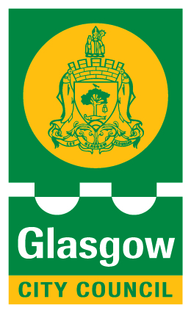
Date: 13 July 2017

Smarter living on Glasgow's horizon
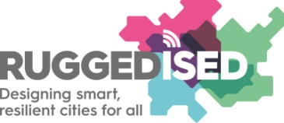

Glasgow has recently received €4.1 million for the development of sustainable solutions in a new smart street district in the city.
The grant was awarded as part of the EU Horizon 2020 programme and is for demonstration projects where Information and Communication Technology (ICT), energy and mobility are being applied in an innovative way and where the public, private and academic sectors are collaborating in an international context.
The money will be used to develop innovative and sustainable applications including intelligent energy management systems which make sharing of energy possible between the various buildings within the smart street - which runs from George Street, Duke Street and ending at the former meat market site.
For the smart street, the city of Glasgow has devised a package of innovative sustainability measures together with the University of Strathclyde, SP Energy Networks, Siemens, Transport Scotland, Tennents Brewery and Glasgow Housing Association. This will involve the deployment sustainable energy sources such as efficient heat networks, solar panels, urban wind turbines, and energy storage installations, along with energy efficiency improvements for local residents.
Counciilor Anna Richardson, Glasgow City Convener for Sustainability and Carbon Reduction, said: "This funding from the European Commission will allow Glasgow to benefit from the use of sustainable technologies in tackling issues such as fuel poverty, ageing infrastructure and air quality.
“Cutting carbon emissions, tackling climate change and increasing access to affordable energy for city residents are key priorities.
“It will help create job opportunities and contribute to improving the quality of life for residents living and working in the smart corridor district.
“Glasgow is striving to become one of the most sustainable and resilient cities in Europe and harnessing renewable energy and securing future energy supplies for our citizens are a major part of that aspiration.
“With this offical acknowledgement by the European Commission, Glasgow will continue its journey initiated by Sustainable Glasgow and Future Cities initiatives, maintaining our position as a leader in the development of sustainable and smart cities.”
In addition to improving energy use in buildings, the project will enhance the provision of electric vehicle charging infrastructure within the smart street area, and explore the opportunities around charging through renewable sources, energy management and support to the local electrical grid.
The project is designed to be complimentary to other projects which are being delivered through European Regional Development Funding, Green Investment Bank and City Deal.
The lessons learned from Glasgow’s project will be disseminated throughout Scotland, via the Scottish Cities Alliance, as well as throughout the UK and the EU.
The official website for the project is http://www.ruggedised.eu

Notes to Editors
The grant is part of the EU Horizon 2020 programme and is meant for demonstration projects where ICT, Energy and Mobility are being applied in an innovative way and whereby public parties are collaborating with market parties and knowledge institutions in an international context.
The EU has drawn up a large, innovative investment agenda for Horizon 2020, for the years 2015-2020, which involves about 80 billion euros.
The European Commission approved the proposal of an international consortium led by the City of Rotterdam and including Glasgow for a grant of nearly €18 million – €4.1m of which is for Glasgow projects.
The rest of the grant will be distributed between projects in other cities within the consortium: Rotterdam in Holland, Umeå in Sweden, Brno in Czech Republic, Parma in Italy and Gdansk in Poland.
The smart street district is an area extending from the City Chambers and the University of Strathclyde, along George Street and Duke Street and terminating at the former Meat Market Development site.
ENDS

